**Visual images for Rania Jawad’s entry on “Palestinian Theatre”**

صندوق العجب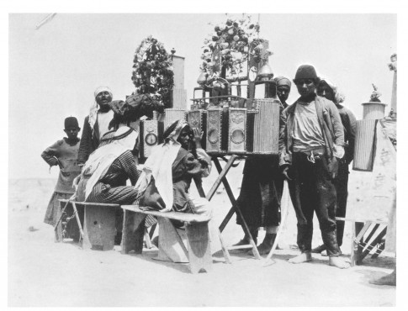

Caption:

صندوق العجب [Sanduq al-‘Ajab]. This picture is taken in Palestine sometime between 1918-1935.

[from: *Before Their Diaspora*, Walid Khalidi]

draws on such indigenous performance traditions

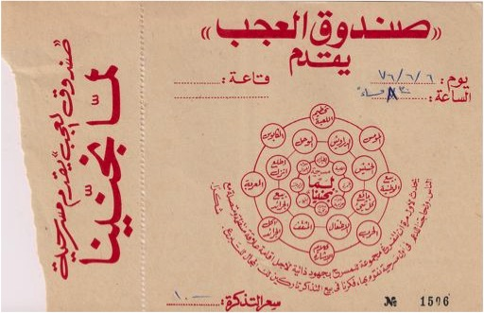

Caption:

Ticket stub for the play"لما انجنينا" [When We Went Mad] by مسرح صندوق العجب [Masrah Sanduq al-‘Ajab], dated 6 June 1976. The troupe’s name references an Arab theatrical artform present in Palestine for years. The play documents the everyday social realities of two Palestinian laborers in Israel and their descent into madness.

[personal photo; ticket stub courtesy of personal archive of Sanduq al-‘Ajab Theatre Troupe member ‘Adel al-Tartir]

"ام الروبابيكيا"

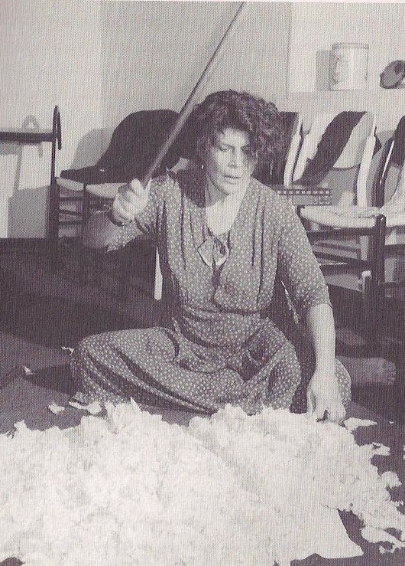

Caption:

Actress Bushra Kamran in Emile Habibi’s highly intertextual monodrama"ام الروبابيكيا" [Umm al-Rubabikiya, The Mother of Second-Hand Things], which opened in Acre in 1992.

rupture caused by the Nakba

<http://www.youtube.com/watch?feature=player_embedded&v=Netr9Nr3G9A>

(beginning to 1:34)

Caption:

Trailer for theatre troupe ShiberHur’s play"اذ قال يوسف" [English title: I Am Yusuf and This is My Brother], produced in 2010 and directed by Amir Nizar Zuabi. The play narrates the story of a Palestinian village before, during, and after the 1948 *Nakba* [the “catastrophe” in Arabic, referring to the establishment of the Israeli state on Palestinian lands].

questions of identity

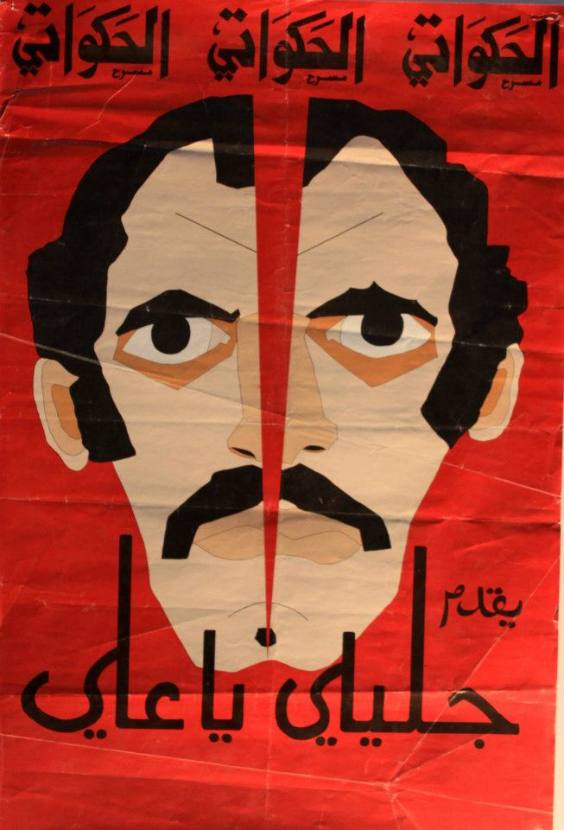

Caption:

The poster for "جليلي يا علي" [Jalili ya ‘Ali, Ali the Galilean], a play of مسراح الحكاواتي [Masrah al-Hakawati, The Storyteller Theatre Troupe] in the early 1980s that satirically

addresses the status of Palestinians living in Israel and the politics of representation.

*Rijal fi-l Shams*

Picture of riad masarwe’s production to insert

Caption:

Riad Masarwe’s theatre production of Ghassan Kanafani’s novella *Rijal fi al-Shams*, first staged in Nazareth in 1977. The play was produced in the wake of Kanafani’s assassination by the Israeli Mossad in Beirut in 1972, and the events of Land Day in 1976. Land Day commemorates the general strike organized in the Galilee in protest of expanded Israeli land confiscation policies of Palestinian lands inside the Israeli state. Six Palestinians who hold Israeli citizenship were killed by Israeli forces and hundreds imprisoned.

Conditions of injustice around the world

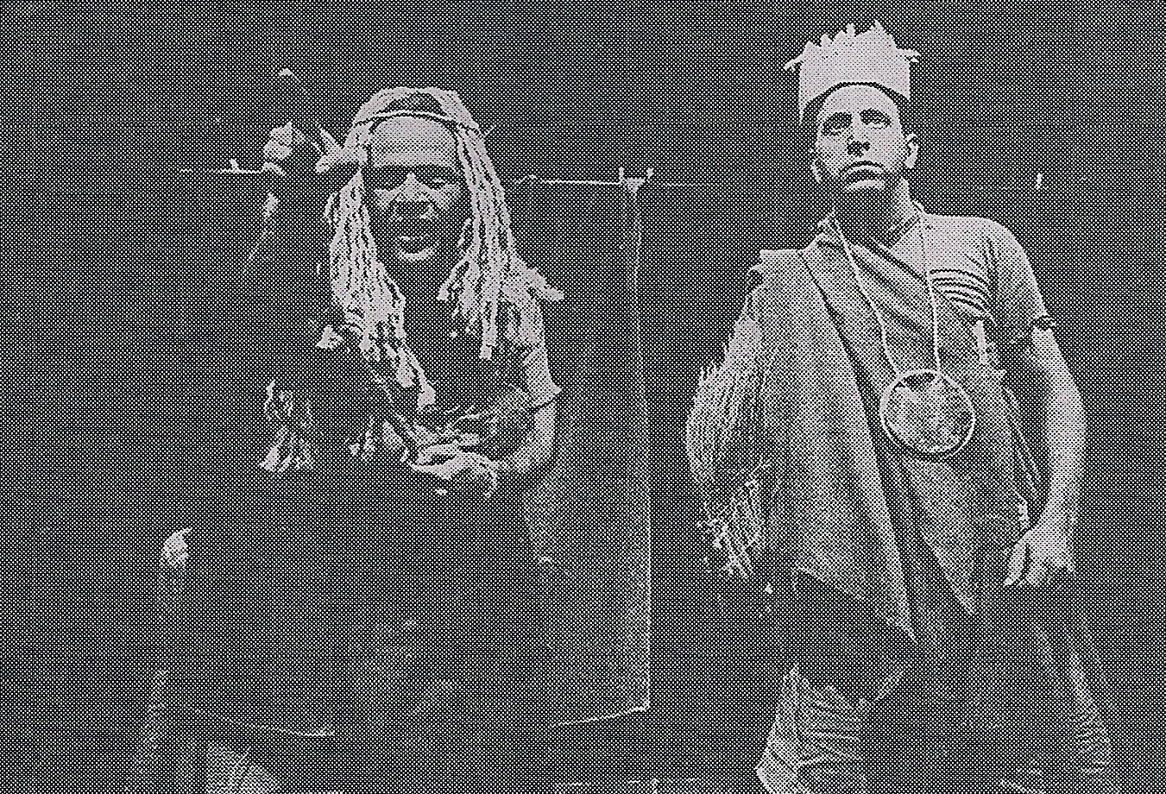

Caption:

A 1983 adaptation of South African theatre practitioner Athol Fugard’s *The Island*, acted by Makram Khoury (right) and Yusef Abu Warde (left). The play follows two black prisoners as they put on a production of *Antigone* for their inmates.

—insert picture of Juliano’s Death and the Maiden

Caption:

A 2011 adaptation of Chilean playwright Ariel Dorfman’s *Death and the Maiden*. Directed by Juliano Mer-Khamis, acted by Clara Khoury, Amer Hlehel, and Saleh Bakri. The play depicts the trauma of a former female political prisoner who was tortured and raped under a repressive dictatorship.